Reference: Waves and Sound
Difficulty: moderate
Learning Objective: E2.7
Contest: 1997

The natural frequency of a string varies directly as the square root of the tension in the string. Two identical strings have a tension of 100 N and sound a frequency of 50 Hz. The tension is reduced in one of the strings. What is this tension if the two strings now produce 10 beats every second when sounded together?

A) 89 N
B) 80 N
C) 64 N
D) 8.9 N
E) 8.0 N

Answer: C
Reference: Waves and Sound
Difficulty: moderate
Learning Objective: None
Contest: 1997

When measured with a decibel meter, a subway train registers 1.0 × 10² dB and normal breathing is read as 10 dB. The sound from the subway train is

A) 10 times more intense
B) 90 times more intense
C) 100 times more intense
D) 1000 times more intense
E) 1.0 × 10⁹ times more intense

Answer: E
Reference: Waves and Sound
Difficulty: difficult
Learning Objective: None
Contest: 1997

Two identical simple pendulum clocks keep perfect time when their pendula are 100 cm long. George bumps into one of the clocks and causes its bob to slip so that the pendulum is now 102 cm long and no longer keeps correct time. Both clocks are started running with their pendula in phase. How much time will elapse before the two pendula are back in phase again?

for a pendulum
A) 32.7 s
B) 100 s
C) 102 s
D) 201 s
E) 204 s

Answer: B
Reference: Waves and Sound
Difficulty: easy
Learning Objective: E3.1
Contest: 1998

You are sitting in an anchored boat. You see water waves that vibrate with a frequency of 0.30 Hz travelling North. The distance from crest to crest is 8.0 m. You start travelling with a velocity of 2.4 m/s [North]. What is the frequency of the waves hitting the front of your boat now?

A) 0 Hz
B) 0.30 Hz
C) 2.4 Hz
D) 2.7 Hz
E) 3.0 Hz

Answer: A
Reference: Waves and Sound
Difficulty: moderate
Learning Objective: E2.3
Contest: 1998

Inside a tube open at both ends, a tiny speaker creates sound that resonates at a fundamental frequency of 1000 Hz. What will be that frequency if the column is closed at both ends/

A) 500 Hz
B) 1000 Hz
C) 2000 Hz
D) 250 Hz
E) 4000 Hz

Answer: B
Reference: Waves and Sound
Difficulty: moderate
Learning Objective: E2.4
Contest: 1998

A sonar fishfinder on an ocean fishing boat emits a beam with a frequency of 28 kHz. If the wavelength of the sound travelling to the bottom of the ocean is 5.3 cm, calculate the time for the wave to reach the ocean bottom which is 100 m below the boat.

A) 6.7 × 10¹ s
B) 6.7 × 10⁻² s
C) 3.4 × 10⁻² s
D) 3.4 × 10¹ s
E) 1.4 × 10⁻¹ s

Answer: B
Reference: Waves and Sound
Difficulty: moderate
Learning Objective: E3.3
Contest: 1998

A tuning fork vibrating at an unknown frequency is placed next to a loudspeaker driven at a frequency f. With f = 1500 Hz, a beat frequency of 3 Hz is heard. With f = 1503 Hz, a beat frequency of 6 Hz is hears. With what other f could you produce a 6 Hz beat frequency?

A) 1491 Hz
B) 1494 Hz
C) 1497 Hz
D) 1509 Hz
E) 1515 Hz

Answer: A
Reference: Waves and Sound
Difficulty: moderate
Learning Objective: E3.3
Contest: 1999

A guitar string sounded at the same time as a 512 Hz tuning fork produces 20 beats in 4.0 seconds. The string is tightened and 2.0 beats/s are now heard. What was the original frequency of the guitar string?

A) 492 Hz
B) 507 Hz
C) 510 Hz
D) 517 Hz
E) 532 Hz

Answer: B
Reference: Waves and Sound
Difficulty: moderate
Learning Objective: E2.7
Contest: 1999

A car has a loose bolt in the dashboard with a natural frequency of 5.0 Hz. It vibrates in resonance whenever the car reaches a certain speed, because one of the car’s tires is unbalanced and “bumps” the car once each rotation. If the radius of the tire is 36 cm, what is the car’s speed, when the bolt vibrates?

A) 7.2 cm/s
B) 45 cm/s
C) 5.7 m/s
D) 11 m/s
E) 72 km/h

Answer: D
Reference: Waves and Sound
Difficulty: easy
Learning Objective: E2.4
Contest: 1999

Which of the following statements correctly describes the changes that occur in a sound wave, as it passes from cool air into warmer air?

A) Speed, wavelength and frequency all increase.
B) Speed, wavelength increase; frequency decreases.
C) Speed, wavelength increase; frequency unchanged.
D) Speed, frequency decrease; wavelength increases.
E) Speed, frequency decrease; wavelength unchanged.

Answer: C
Reference: Waves and Sound
Difficulty: easy
Learning Objective: E3.4
Contest: 2000

Which wave of the following wavelengths could NOT make a standing wave in a 1.0 m string, with nodes at both ends?

A) 2.0 m
B) 1.0 m
C) 0.75 m
D) 0.50 m
E) 0.25 m

Answer: C
Reference: Waves and Sound
Difficulty: moderate
Learning Objective: E2.3
Contest: 2000

An open-ended air column of length 35 cm resonates with a speaker sounding a 500 Hz note. If the air is vibrating in the fundamental mode, what temperature is the air? (Recall: speed of sound = 332 + 0.60T m/s, where T is temperature in Celsius degrees)

A) –262°C
B) 0°C
C) 18°C
D) 30°C
E) 637°C

Answer: D
Reference: Waves and Sound
Difficulty: easy
Learning Objective: E2.1
Contest: 2000

A long pendulum is pulled aside so its string is 5° to the vertical. When the bob is released from rest, it takes 0.10 s to return to vertical. If the bob is now pulled out to 10°, and released from rest, the time that it will take to return to vertical is closest to

A) 0.050 s
B) 0.10 s
C) 0.14 s
D) 0.15 s
E) 0.20 s

Answer: B
Reference: Waves and Sound
Difficulty: easy
Learning Objective: E3.3
Contest: 2001

Which of the following phenomena is not considered as an interference effect?

A) air column resonance
B) the Doppler effect
C) beats
D) standing waves in a string
E) all the above are interference effects

Answer: B
Reference: Waves and Sound
Difficulty: moderate
Learning Objective: E2.4
Contest: 2001

Radio station CDB broadcasts at a frequency of 102.1 MHz and uses a quarter wave antenna. The height of antenna required is approximately:

A) 75 cm
B) 150 cm
C) 300 cm
D) 102.1 m
E) 102.1 km

Answer: A
Reference: Waves and Sound
Difficulty: easy
Learning Objective: E2.1
Contest: 2001

A large pendulum was constructed at the south pole, and set vibrating. Six hours later the plane of vibration will have rotated through an angle of:

A) 0º
B) 90º
C) 180º
D) 270º
E) 360º

Answer: B
Reference: Waves and Sound
Difficulty: easy
Learning Objective: E2.7
Contest: 2001

A guitar string is stretched as shown from point A to G. Equal intervals are marked off by B, C, D, E and F. Paper folders are placed in locations D, E and F. The string is pinched at C and twanged at B. What happens?
A
B
C
D
E
F
G

A) All of the riders will jump off
B) None of the riders will jump off
C) The rider at E jumps off
D) The riders at D and F jump off
E) The riders at E and F jump off

Answer: D
Reference: Waves and Sound
Difficulty: easy
Learning Objective: E3.4
Contest: 2001

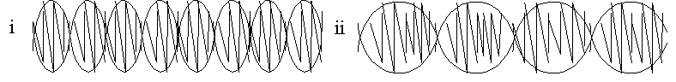Two different notes are sounded at the same time. The sound waves for the two notes are added and the sum is shown in display (i). Then a different pair of notes is sounded and their sum is shown in display (ii). Which pair of notes is closer in frequency?

A) display (i)
B) Notes shown in display (i) are as close in frequency as display (ii)
C) display (ii)
D) display (i) is identical to display (ii)
E) It is not possible from the displays to tell which pair of notes is closer in frequency

Answer: C
Reference: Waves and Sound
Difficulty: moderate
Learning Objective: E2.7
Contest: 2002

Fritz plucked the low “E” string on his guitar, and let it sound. A few seconds later he noticed that the high “E” string, which is two octaves above the low “E” string, was also vibrating. Each octave increase doubles the frequency. He concluded that the high “E” string was resonating with the ___ harmonic of the low “E” string.

A) first
B) second
C) third
D) fourth
E) eighth

Answer: D
Reference: Waves and Sound
Difficulty: easy
Learning Objective: E3.4
Contest: 2002

While watching the waves on a rough lake, Andree noticed that a large wave would “rise” for a few seconds, and then diminish. This was most likely caused by

A) constructive interference.
B) destructive interference.
C) standing waves in the water.
D) the Doppler effect.
E) resonance.

Answer: A
Reference: Waves and Sound
Difficulty: difficult
Learning Objective: E2.3, E2.4
Contest: 2002

The speed of sound in air at 0°C is 332 m/s, and increases by 0.60 m/s for every degree Celsius that the temperature rises. A piano tuner strikes a key that produces a 440 Hz “A” note in a room with a temperature of 20ºC. A beat frequency of 26 Hz results when a tuning fork and the key are struck simultaneously. A possible wavelength of the note produced by the tuning fork is

A) 69 cm.
B) 71 cm.
C) 77 cm.
D) 80 cm.
E) 83 cm.

Answer: E
Reference: Waves and Sound
Difficulty: moderate
Learning Objective: E2.7
Contest: 2002

Mikhail found a steel rod one meter long. He held it in the middle, and tapped it with a hammer at one end, creating longitudinal standing waves in the rod. Mikhail knew that sound waves in steel travel at about 5,000 m/s. He heard a fundamental frequency of

A) 10,000 Hz.
B) 5,000 Hz.
C) 2,500 Hz.
D) 1,250 Hz.
E) cannot be determined from this information.

Answer: C
Reference: Waves and Sound
Difficulty: moderate
Learning Objective: E2.3, E2.4
Contest: 2002

A student performed an experiment using an air column closed at one end. An 880 Hz turning fork was sounded near the open end while the length of the column was adjusted. Loud sounds were heard at 9.7 cm and 29.1 cm. The room temperature at the time was close to

A) 0.0°C.
B) 13.3°C.
C) 15.7°C.
D) 18.3°C.
E) 20.0°C.

Answer: C
Reference: Waves and Sound
Difficulty: easy
Learning Objective: E2.1
Contest: 2003

If a pendulum clock is running slow, you could correct the time by

A) increasing the mass density of the pendulum, keeping its length the same.
B) decreasing the mass density of the pendulum, keeping its length the same.
C) increasing the length of the pendulum, keeping its mass the same.
D) decreasing its amplitude.
E) decreasing the length of the pendulum, keeping its mass the same.

Answer: E
Reference: Waves and Sound
Difficulty: moderate
Learning Objective: E2.3, E2.4
Contest: 2003

A long tube open at both ends was held vertically with one end under water as shown. A tuning fork of frequency 430 Hz was struck and held over the upper open end of the tube. As the tube was lifted, successive loud sounds were heard at h = 60 cm and h = 100 cm. Given that the speed of sound in air is 332 m/s at 0° C and increases at 0.6 m/s per Celsius degree, what was the temperature of the air in the tube?

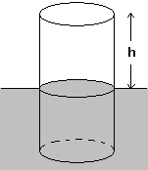

A) 0°C
B) 10°C
C) 15°C
D) 20°C
E) 25°C

Answer: D
Reference: Waves and Sound
Difficulty: easy
Learning Objective: E3.3
Contest: 2003

A piano tuner sounded a tuning fork of frequency 440 Hz and struck the A string on a piano. He heard a beat frequency of 2 Hz. He used his tuning hammer to increase the tension of the string, and struck it again with the fork. This time he heard a beat frequency of 3 Hz. We can be certain that:

A) the tension in the string should have been decreased, not increased.
B) the string is getting closer to the correct tuning, and the tension should be increased more.
C) the tuner has increased the tension past the desired tuning, and should now decrease the tension.
D) either A) or C) is correct.
E) the string is defective, and cannot be properly tuned.

Answer: D
Reference: Waves and Sound
Difficulty: easy
Learning Objective: E2.5
Contest: 2003

A motionless train emits a sound at a frequency of 1000 Hz. An observer in a moving car hears a frequency of 1100 Hz. If the velocity of sound in air is 340 m/s, the car is moving

A) towards the train with a velocity 34 m/s.
B) away from the train with a velocity 34 m/s.
C) away from the train with a velocity 31 m/s.
D) towards the train with a velocity 31 m/s.
E) cannot be determined.

Answer: A
Reference: Waves and Sound
Difficulty: easy
Learning Objective: E3.4
Contest: 2003

A student tied a rope to a wall, and moved the free end up and down at a frequency of 2.5 Hz. A pattern of standing waves formed as shown. What was the speed of these waves?
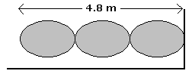

A) 2.5 m/s
B) 4.0 m/s
C) 4.8 m/s
D) 6.4 m/s
E) 8.0 m/s

Answer: E
Reference: Waves and Sound
Difficulty: easy
Learning Objective: E2.4
Contest:

Two toy ducks are floating in a lake 12 m apart. They are bobbing up and down 25 cm above and below the lake level with a period of 2 seconds. Find the speed of the waves.

A) 1.5 m/s
B) 2.0 m/s
C) 3.0 m/s
D) 6.0 m/s
E) There is not enough information to determine a correct answer.

Answer: E
Reference: Waves and Sound
Difficulty: easy
Learning Objective: E3.3
Contest: 2004

Two loudspeakers are placed about 70 centimeters apart on a desk such that they face west. Each speaker is emitting sound with the same frequency and with the same intensity. You are asked to slowly walk north in front of the loudspeakers. As you do so, you hear alternate soft and loud sounds. This effect is best explained by

A) reflection
B) refraction
C) dispersion
D) interference
E) diffraction

Answer: D
Reference: Waves and Sound
Difficulty: moderate
Learning Objective: E2.3, E2.4
Contest: 2004

The speed of sound in air at 0ºC is 332 m/s, and increases by 0.60 m/s for every degree Celsius that the temperature rises. A piano tuner strikes a key which vibrates at 1024 Hz in a room with a temperature of 20ºC. A beat frequency of 26 Hz results when a tuning fork and the key are struck simultaneously: A possible wavelength of the note produced by the tuning fork is

A) 30 cm.
B) 33 cm.
C) 36 cm.
D) 64 cm.
E) 70 cm.

Answer: B
Reference: Waves and Sound
Difficulty: moderate
Learning Objective: E2.5
Contest: 2004

An observer was standing on a railroad platform. A train leaving the station blew its whistle at 500 Hz. A train at rest in the station joined in with the same frequency. The observer heard

A) beats at 0 Hz.
B) beats at more than 0 Hz but less than 500 Hz.
C) beats at 500 Hz.
D) beats at more than 500 Hz.
E) nothing. The sounds will cancel each other.

Answer: B
Reference: Waves and Sound
Difficulty: moderate
Learning Objective: E2.3
Contest: 2004

An air column open at one end only is increased in length The air column first resonates with a given tuning fork when the length of the air column reaches 20 cm. The next two consecutive lengths that will resonate with the same tuning fork will measure

A) 30 cm and 40 cm.
B) 40 cm and 60 cm.
C) 60 cm and 90 cm.
D) 60 cm and 100 cm.
E) 80 cm and 100 cm.

Answer: D
Reference: Waves and Sound
Difficulty: moderate
Learning Objective: E2.3, E2.4
Contest: 2005

A vibrator was placed in contact with a solid. It was driven at a frequency of 1.24 kHz, and created standing waves in the solid. A detector was slid along the solid. Successive signal maxima occurred at the following distances from the end: 14.3 cm, 42.9 cm, 71.5 cm and 100.1 cm. What was the speed of sound in this solid?


A) 177 m/s
B) 355 m/s
C) 532 m/s
D) 709 m/s
E) 1240 m/s

Answer: D
Reference: Waves and Sound
Difficulty: moderate
Learning Objective: E2.3
Contest: 2005

Two air columns have the same length. Column A is closed at one end and column B is open at both ends. A signal generator was used to set each vibrating at its third lowest resonant frequency. The ratio of the third lowest resonant frequency of column A to the third lowest resonant frequency of column B is

A) $\frac{1}{2}$
B) $\frac{3}{4}$
C) $\frac{4}{3}$
D) $\frac{6}{5}$
E) $\frac{5}{6}$

Answer: E
Reference: Waves and Sound
Difficulty: easy
Learning Objective: E2.5
Contest: 2005

A student attached a buzzer to the bob of a pendulum. The buzzer produced a note of constant frequency 1000 Hz. The pendulum was set in motion, swinging from A toward B, as shown. When will an observer at point P hear the highest frequency?
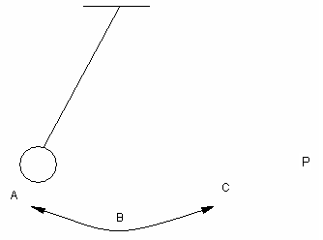

A) When the bob is at point A.
B) When the bob is at point C.
C) When the bob is at point B, moving towards the observer.
D) When the bob is at point B, moving away from the observer.
E) The observer will always hear a frequency of 1000 Hz.

Answer: C
Reference: Waves and Sound
Difficulty: easy
Learning Objective: E3.3
Contest: 2005

Pilots often use headsets with active noise reduction (ANR) to reduce ambient noise in the cockpit environment by canceling the noise electronically. These headsets principally make use of

A) resonance
B) standing waves
C) phase shift
D) the principle of superposition
E) reflection

Answer: D
Reference: Waves and Sound
Difficulty: easy
Learning Objective: E3.4
Contest: 2005

The walls and ceiling of a concert hall are usually constructed with irregular surfaces, and parallel or perpendicular surfaces are avoided. This is done to

A) avoid standing wave patterns from forming.
B) favour the formation of standing wave patterns.
C) increase the time taken for a sound made in the hall to die out.
D) increase the speed of sound in the hall.
E) create a visually pleasing environment for the audience.

Answer: A
Reference: Waves and Sound
Difficulty: easy
Learning Objective: E3.3
Contest: 2006

Two waves are generated in a spring, one from each end, moving towards each other, as shown. Which of the following best represents the shape of the spring when the two exactly overlap?
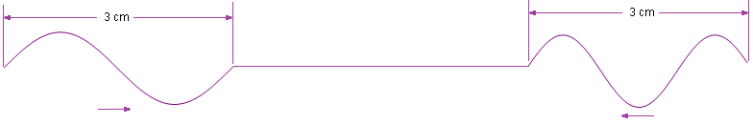

A) B) C) D) E)

Answer: A
Reference: Waves and Sound
Difficulty: easy
Learning Objective: E2.3
Contest: 2006

15) A pipe organ has a frequency range of 20 Hz to 20 kHz. The longest pipe has a length of x, while the shortest pipe has a length of y. If the speed of sound is 340 m/s, what is the value of the ratio x:y?

A) 1.0 × 10^{–3}
B) 1.7 × 10^{–2}
C) 8.6
D) 17
E) 1.0 × 10³

Answer: E
Reference: Waves and Sound
Difficulty: moderate
Learning Objective: E3.3
Contest: 2006

Two speakers are situated 4.0 m apart , emitting pure sounds of 850 Hz frequency towards each other. Along the line between the sources, how far apart are the minima caused by superposition of the sound waves? The speed of sound is 340 m/s.
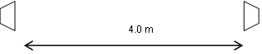

A) 80 cm
B) 40 cm
C) 20 cm
D) 10 cm
E) 2.5 cm

Answer: C
Reference: Waves and Sound
Difficulty: easy
Learning Objective: E3.6
Contest: 2006

As an observer walks down a street past a large, rectangular building, she hears two people talking around the corner. The reason is that

A) sound waves diffract around obstacles.
B) the sound waves reflect from the corner of the building.
C) the sound produces standing waves between the talkers and the building.
D) the temperature is hot enough that the air refracts the sound waves.
E) the temperature is cold enough that the air refracts the sound waves.

Answer: A
Reference: Waves and Sound
Difficulty: Moderate
Learning Objective: E2.6, E2.7
Contest: 2007

Vibrating string A vibrates at a fundamental frequency of 120 Hz, while vibrating string B vibrates at a fundamental frequency of 150 Hz. Which of these pairs of harmonics will have the same frequency?
A) the fifth harmonic of string A and the fourth harmonic of string B
B) the fourth harmonic of string A and the fifth harmonic of string B
C) the third harmonic of string A and the sixth harmonic of string B
D) the sixth harmonic of string A and the third harmonic of string B
E) none of the harmonics will match

Answer: A
Reference: Waves and Sound
Difficulty: Difficult
Learning Objective: E2.6, E2.7
Contest: 2007

The lowest resonant frequency for a certain organ pipe is found to be 70 Hz. The next successive resonances occur at 210 Hz and 350 Hz. If the speed of sound in air is 336 m/s, the pipe is
A) open at both ends and of length 1.2 m.
B) open at both ends and of length 2.4 m.
C) open at both ends and of length 3.6 m.
D) closed at one end and, open at the other, and of length 1.2 m.
E) closed at one end and, open at the other, and of length 2.4 m.

Answer: D
Reference: Waves and Sound
Difficulty: Easy
Learning Objective: E2.5
Contest: 2007

You are at rest. The siren of a police car approaching you is emitting sound at a frequency of 1000 Hz. Due to the Doppler shift, you hear a frequency f. Starting from rest, you accelerate directly away from the police car, in the same direction that it is moving. When your speed matches the speed of the police car, what frequency will you hear?
A) 0.5f
B) f
C) 1.5f
D) 2f
E) 1000 Hz

Answer: E
Reference: Waves and Sound
Difficulty: Moderate
Learning Objective: E2.1
Contest: 2007

Waves were generated at opposite ends of a spring such that they travelled towards each other, as shown. 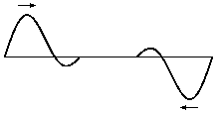
Which diagram represents the waves when they completely overlap each other with their horizontal midpoints lining up?

A) B) C) D) E)
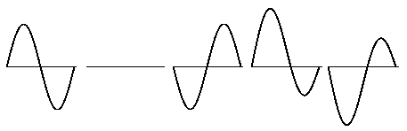

Answer: A

Reference: Waves and Sound
Difficulty: Moderate
Learning Objective: E3.5
Contest: 2007

While cruising the North Atlantic in a fog, a ship blew its horn, and received an echo from an iceberg 4.0 s later. The temperature of the air was 5ºC, the temperature of the iceberg was 0ºC, and the temperature of the water was 2ºC
In order to calculate the distance from the ship to the iceberg, the captain must also know the speed of sound in
A) ice at 0 ºC.
B) water at 2 ºC.
C) water at 0ºC.
D) air at 0 ºC.
E) air at 5 ºC.

Answer: E
Reference: Waves and Sound
Difficulty: Moderate
Learning Objective: E2.1, E2.4
Contest: 2008

A periodic wave with a frequency of 250 Hz and an amplitude of 0.50 cm travels at 175 m/s to create a standing wave in a string. The distance between adjacent nodes and the amplitude of the standing wave are, respectively:

A) 0.35 m and 0.50 cm.
B) 0.35 m and 1.0 cm.
C) 0.70 m and 0.50 cm.
D) 0.70 m and 1.0 cm.
E) 1.4 m and 1.0 cm.

Answer: B
Reference: Waves and Sound
Difficulty: Moderate
Learning Objective: E2.1, E2.3
Contest: 2008

The temperature of the air is 20.0ºC when a tourist drops a coin into a wishing well. She hears the splash 5.30 s after she drops the coin. If air resistance is ignored, how deep is the well?

A) 344 m
B) 332 m
C) 137 m
D) 120 m
E) 0.60 m

Answer: D
Reference: Waves and Sound
Difficulty: Moderate
Learning Objective: E2.1
Contest: 2008

Two waves are generated in a spring, moving in opposite directions, as shown. When the waves overlap completely, which of the following waves will cancel the resultant?

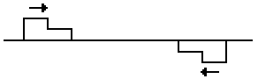

A) B) C) D) E)


Answer: B
Reference: Waves and Sound
Difficulty: Easy
Learning Objective: E2.5
Contest: 2008

An observer standing at a bus stop hears a motorcycle approaching him. The motorcycle rider rides at a constant speed, and passes the observer. Compared to the engine frequency heard by the rider, the observer hears:

A) a constant higher frequency while the motorcycle is approaching, and a constant lower frequency after the motorcycle passes and moves away.
B) a constant lower frequency while the motorcycle is approaching, and a constant higher frequency after the motorcycle passes and moves away.
C) a higher but decreasing frequency while the motorcycle is approaching, and a lower but increasing frequency after the motorcycle passes and moves away.
D) a lower but decreasing frequency while the motorcycle is approaching, and a higher but increasing frequency after the motorcycle passes and moves away.
E) the same constant frequency that the rider hears.

Answer: A
Reference: Waves and Sound
Difficulty: Difficult
Learning Objective: E2.1, E2.3
Contest: 2008

A busker is playing a 440 Hz note on a portable pipe organ on a street corner in Calgary when the air temperature is 0ºC. She holds the note as a Chinook wind passes, which raises the air temperature to 20.0ºC. What is the frequency in the warmer air?

A) 424 Hz
B) 440 Hz
C) 456 Hz
D) 460 Hz
E) 880 Hz

Answer: C
Reference: Waves and Sound
Difficulty: moderate
Learning Objective: E3.4
Contest: 2009

When a guitar string is plucked, standing waves are formed in the string, with a node at each end, and an integral number of antinodes in the string. Such a string is plucked, and lightly touched one-quarter of its length from one end. What number(s) of antinodes is(are) possible?

A) Any integral number.
B) Any even integral number.
C) Any odd integral number.
D) 4 and only 4.
E) Any multiple of 4.

Answer: E
Reference: Waves and Sound
Difficulty: easy
Learning Objective: E2.3
Contest: 2009

You hold a cylindrical tube open at both ends near your ear in a noisy environment, i.e., all audible wavelengths of sound are present. You hear a faint note with a fundamental frequency f. What do you hear when you hold the same tube right against your ear?

A) The same frequency only louder.
B) The same frequency only quieter.
C) A note at half the frequency.
D) A note at twice the frequency.
E) no note

Answer: C
Reference: Waves and Sound
Difficulty: easy
Learning Objective: E3.6
Contest: 2009

Consider sound waves in air. Which of the following statements is not correct?

A) They consist of compressions and rarefactions.
B) They are longitudinal waves.
C) They are a form of energy.
D) They would travel faster in a vacuum than in air.
E) Their speed is temperature dependent.

Answer: D
Reference: Waves and Sound
Difficulty: difficult
Learning Objective: E2.3, E2.4
Contest: 2009

An underwater swimmer sends a sound signal to the surface, where a 20 cm long organ pipe, closed at one end, is producing sound at its fundamental frequency above the surface of the water. The speed of sound in air is 320 m/s, while the speed of sound in water is 1600 m/s. What is the wavelength of the sound wave in the water, to the nearest metre?

A) 6 m
B) 5 m
C) 4 m
D) 3 m
E) 2 m

Answer: C
Reference: Waves and Sound
Difficulty: moderate
Learning Objective: E2.1
Contest: 2009

Two pendulums have the same period T, and are set to vibrate a few meters apart along the same east-west line. The first pendulum has a loudspeaker attached, producing a frequency of 440 Hz. The second has a wireless microphone attached. The bobs of the pendulums are pulled in opposite directions to the same amplitude, and released simultaneously. When will the frequency of the sound picked up by the microphone reach a maximum?
A) T
B) 0.75T
C) 0.5 T
D) 0.25T
E) The frequency will remain constant at 440 Hz.

Answer: D
Reference: Waves and Sound
Difficulty: easy
Learning Objective: E3.1
Contest: 2010

Consider the graphs of two sound waves represented by the red line, and the blue line. Which statement is true?
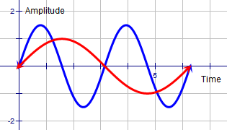

A) The red wave has a higher amplitude and a higher frequency than the blue wave.
B) The red wave has a higher amplitude but a lower frequency than the blue wave.
C) The red wave has a lower amplitude but a higher frequency than the blue wave.
D) The red wave has a lower amplitude and a lower frequency than the blue wave.
E) The two sound waves have the same amplitude and frequency.

Answer: D
Reference: Waves and Sound
Difficulty: easy
Learning Objective: E3.3
Contest: 2010

The frequency of tuning fork A is slightly higher than tuning fork B. By sounding them together, beats can be produced. If tuning fork B is loaded with wax on its prongs, the beat frequency will

A) oscillate periodically.
B) increase.
C) remain the same.
D) decrease.
E) become zero

Answer: B
Reference: Waves and Sound
Difficulty: moderate
Learning Objective: E3.3
Contest: 2010

Two loudspeakers are separated by 0.50 m on one wall of a room measuring 3.5 m by 7.0 m at a temperature of 22°C. Both speakers generate a constant amplitude sound of frequency 690 Hz, in phase with each other, radiating equally in all directions. What is the shortest distance x along the adjacent wall where an observer will hear no sound? Ignore any reflections from the walls.
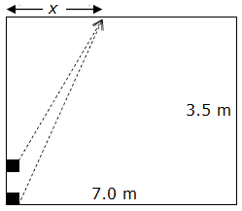

A) 0 m
B) 0.25 m
C) 3.7 m
D) 5.6 m
E) There is no such point within the room.

Answer: D
Reference: Waves and Sound
Difficulty: easy
Learning Objective: E3.3
Contest: 2010

Two waves were created at opposite ends of a spring such that they travelled towards each other, as shown.

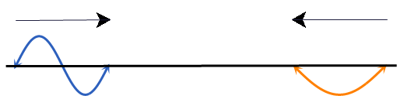

Which pattern best models the resultant wave at the instant that the two waves exactly overlap?
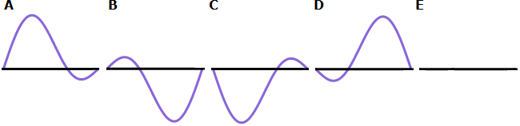

Answer: B
Reference: Waves and Sound
Difficulty: difficult
Learning Objective: E2.3, E2.4
Contest: 2010

An air column open at one end and closed at the other has a fundamental resonance frequency of 100 Hz at a temperature of –123.0°C. The speed of sound in air is directly proportional to the square root of the temperature measured in kelvins (K). What is the resonant frequency at 27.0°C?

A) 50.0 Hz
B) 71.0 Hz
C) 100 Hz
D) 140 Hz
E) 200 H

Answer: D
Reference: Waves and Sound
Difficulty: easy
Learning Objective: E3.1
Contest: 2011

Waves in a string are represented by the displacement versus time graph shown. What does the interval PQ represent?
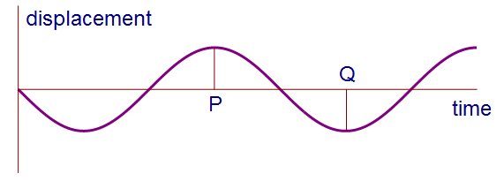

A) half the wavelength
B) the wavelength
C) the period
D) half the period
E) half the frequency

Answer: D
Reference: Waves and Sound
Difficulty: easy
Learning Objective: E3.6
Contest: 2011

Which of the following does not operate using electromagnetic waves?

A) a cell phone
B) a medical ultrasound
C) an infrared heater
D) a fluorescent lamp
E) a dental X-ray

Answer: B
Reference: Waves and Sound
Difficulty: moderate
Learning Objective: E2.7
Contest: 2011

A marimba is a musical instrument that is made with bars of wood that are pegged one-quarter of their lengths from each end, and struck in the middle to produce standing waves in the wood. A length of wood is to be cut to form two of the bars such that one has twice the frequency of the other. How far from one end should the length be cut?
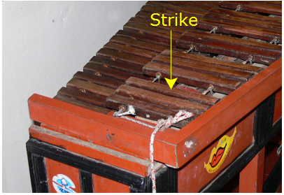

A)
B)
C)
D)
E)

Answer: A
Reference: Waves and Sound
Difficulty: moderate
Learning Objective: E2.3
Contest: 2011

A cylindrical tube open at both ends has a fundamental frequency f in air. The tube is held vertically and partially immersed in water such that half of it is in the water. What is the fundamental frequency of the air column?

A)
B)
C) f
D) 2f
E)

Answer: C
Reference: Waves and Sound
Difficulty: difficult
Learning Objective: E2.4
Contest: 2011

On a pleasant spring day when the air temperature was 20.0°C, a hiker discovered an old well. She dropped a stone into the well, and heard the splash as the stone hit the water 1.63 s later. How deep was the well? Ignore air resistance and variations in the temperature of the air.

A) 7.99 m
B) 12.4 m
C) 13.0 m
D) 541 m
E) 560 m

Answer: B
Reference: Waves and Sound
Difficulty: moderate
Learning Objective: E3.1
Contest: 2012

Two sound waves, S₁ and S₂, are shown on a graph of displacement versus time. What are the ratios of the amplitudes and frequencies of S₁ to S₂?
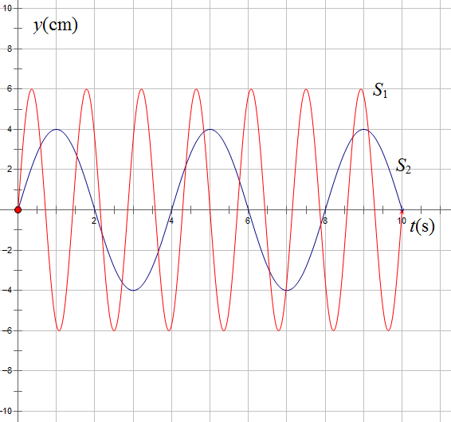

A) 3:1 and 3:1
B) 3:2 and 3:1
C) 3:2 and 1:3
D) 2:1 and 3:1
E) 3:1 and 2:1

Answer: B
Reference: Waves and Sound
Difficulty: easy
Learning Objective: E2.5
Contest: 2012

A train whistle emits a sound of amplitude A and frequency f. An observer however hears a sound with an amplitude much less than A and a frequency greater than f. Which statement is true?
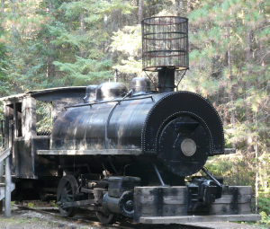

A) The train is at a large distance from the observer and moving away from the observer.
B) The train is at a large distance from the observer and approaching the observer.
C) The train is at a large distance from the observer and at rest.
D) The train is near the observer and moving away from the observer.
E) The train is near the observer and approaching the observer.

Answer: B
Reference: Waves and Sound
Difficulty: easy
Learning Objective: E2.3
Contest: 2012

A student is using a tuning fork and an open tube 40 cm in length placed into water to measure the speed of sound in air using resonance. Which tuning fork, of those listed, will provide the greatest number of resonances?

A) 128 Hz
B) 256 Hz
C) 384 Hz
D) 1024 Hz
E) none

Answer: D

Reference: Waves and Sound
Difficulty: easy
Learning Objective: E3.3
Contest: 2012

When a tuning fork of frequency 256 Hz is struck at the same time as a tuning fork of an unknown frequency, 8 beats are heard within 2 seconds. What is a possible value of the unknown frequency?

A) 240 Hz
B) 248 Hz
C) 252 Hz
D) 256 Hz
E) 264 Hz

Answer: C
Reference: Waves and Sound
Difficulty: moderate
Learning Objective: E2.4
Contest: 2012

A projectile is launched horizontally with an initial speed v. The projectile reaches an observer situated 1,020 m horizontally from the launch point 2.00 s before the observer hears the sound of the launch. The speed of sound in air is 340 m/s. The change in height is negligible. What is the initial speed of the projectile?
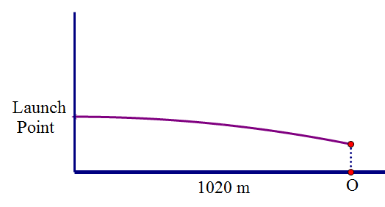

A) 6.80 x 10² m/s
B) 8.70 x 10² m/s
C) 1.02 x 10³ m/s
D) 1.36 x 10³ m/s
E) 1.50 x 10³ m/s

Answer: C
Reference: Waves and Sound
Difficulty:
Learning Objective:
Contest:

A)
B)
C)
D)
E)

Answer:
Reference: Waves and Sound
Difficulty:
Learning Objective:
Contest:

A)
B)
C)
D)
E)

Answer:
Reference: Waves and Sound
Difficulty:
Learning Objective:
Contest:

A)
B)
C)
D)
E)

Answer:
Reference: Waves and Sound
Difficulty:
Learning Objective:
Contest:

A)
B)
C)
D)
E)

Answer:
Reference: Waves and Sound
Difficulty:
Learning Objective:
Contest:

A)
B)
C)
D)
E)

Answer:
Reference: Waves and Sound
Difficulty:
Learning Objective:
Contest:

A)
B)
C)
D)
E)

Answer:
Reference: Waves and Sound
Difficulty:
Learning Objective:
Contest:

A)
B)
C)
D)
E)

Answer:
Reference: Waves and Sound
Difficulty:
Learning Objective:
Contest:

A)
B)
C)
D)
E)

Answer:
Reference: Waves and Sound
Difficulty:
Learning Objective:
Contest:

A)
B)
C)
D)
E)

Answer:
Reference: Waves and Sound
Difficulty:
Learning Objective:
Contest:

A)
B)
C)
D)
E)

Answer:
Reference: Waves and Sound
Difficulty:
Learning Objective:
Contest:

A)
B)
C)
D)
E)

Answer:
Reference: Waves and Sound
Difficulty:
Learning Objective:
Contest:

A)
B)
C)
D)
E)

Answer:
Reference: Waves and Sound
Difficulty:
Learning Objective:
Contest:

A)
B)
C)
D)
E)

Answer:
Reference: Waves and Sound
Difficulty:
Learning Objective:
Contest:

A)
B)
C)
D)
E)

Answer:
Reference: Waves and Sound
Difficulty:
Learning Objective:
Contest:

A)
B)
C)
D)
E)

Answer:
Reference: Waves and Sound
Difficulty:
Learning Objective:
Contest:

A)
B)
C)
D)
E)

Answer:
Reference: Waves and Sound
Difficulty:
Learning Objective:
Contest:

A)
B)
C)
D)
E)

Answer:
Reference: Waves and Sound
Difficulty:
Learning Objective:
Contest:

A)
B)
C)
D)
E)

Answer:
Reference: Waves and Sound
Difficulty:
Learning Objective:
Contest:

A)
B)
C)
D)
E)

Answer:

Reference: Waves and Sound
Difficulty:
Learning Objective:
Contest:

A)
B)
C)
D)
E)

Answer:
Reference: Waves and Sound
Difficulty:
Learning Objective:
Contest:

A)
B)
C)
D)
E)

Answer:
Reference: Waves and Sound
Difficulty:
Learning Objective:
Contest:

A)
B)
C)
D)
E)

Answer:
Reference: Waves and Sound
Difficulty:
Learning Objective:
Contest:

A)
B)
C)
D)
E)

Answer:

Reference: Waves and Sound
Difficulty:
Learning Objective:
Contest:

A)
B)
C)
D)
E)

Answer:
Reference: Waves and Sound
Difficulty:
Learning Objective:
Contest:

A)
B)
C)
D)
E)

Answer:
Reference: Waves and Sound
Difficulty:
Learning Objective:
Contest:

A)
B)
C)
D)
E)

Answer:
Reference: Waves and Sound
Difficulty:
Learning Objective:
Contest:

A)
B)
C)
D)
E)

Answer:
Reference: Waves and Sound
Difficulty:
Learning Objective:
Contest:

A)
B)
C)
D)
E)

Answer:
Reference: Waves and Sound
Difficulty:
Learning Objective:
Contest:

A)
B)
C)
D)
E)

Answer:
Reference: Waves and Sound
Difficulty:
Learning Objective:
Contest:

A)
B)
C)
D)
E)

Answer:
Reference: Waves and Sound
Difficulty:
Learning Objective:
Contest:

A)
B)
C)
D)
E)

Answer:
Reference: Waves and Sound
Difficulty:
Learning Objective:
Contest:

A)
B)
C)
D)
E)

Answer:
Reference: Waves and Sound
Difficulty:
Learning Objective:
Contest:

A)
B)
C)
D)
E)

Answer:
Reference: Waves and Sound
Difficulty:
Learning Objective:
Contest:

A)
B)
C)
D)
E)

Answer:
Reference: Waves and Sound
Difficulty:
Learning Objective:
Contest:

A)
B)
C)
D)
E)

Answer:
Reference: Waves and Sound
Difficulty:
Learning Objective:
Contest:

A)
B)
C)
D)
E)

Answer:
Reference: Waves and Sound
Difficulty:
Learning Objective:
Contest:

A)
B)
C)
D)
E)

Answer:
Reference: Waves and Sound
Difficulty:
Learning Objective:
Contest:

A)
B)
C)
D)
E)

Answer:
Reference: Waves and Sound
Difficulty:
Learning Objective:
Contest:

A)
B)
C)
D)
E)

Answer:
Reference: Waves and Sound
Difficulty:
Learning Objective:
Contest:

A)
B)
C)
D)
E)

Answer:
Reference: Waves and Sound
Difficulty:
Learning Objective:
Contest:

A)
B)
C)
D)
E)

Answer:
Reference: Waves and Sound
Difficulty:
Learning Objective:
Contest:

A)
B)
C)
D)
E)

Answer:
Reference: Waves and Sound
Difficulty:
Learning Objective:
Contest:

A)
B)
C)
D)
E)

Answer:
Reference: Waves and Sound
Difficulty:
Learning Objective:
Contest:

A)
B)
C)
D)
E)

Answer:

Reference: Waves and Sound
Difficulty:
Learning Objective:
Contest:

A)
B)
C)
D)
E)

Answer:
Reference: Waves and Sound
Difficulty:
Learning Objective:
Contest:

A)
B)
C)
D)
E)

Answer:
Reference: Waves and Sound
Difficulty:
Learning Objective:
Contest:

A)
B)
C)
D)
E)

Answer:
Reference: Waves and Sound
Difficulty:
Learning Objective:
Contest:

A)
B)
C)
D)
E)

Answer:

